Flow Charts of SmartHomeServer

Table of Contents

Introduction 2

Class Structures 2

package SmartHomeServer -> class Device 2

package SmartHomeServer -> class SmartHomeServer 3

Flow Chart of SmartHomeServer 3

Legends of colour code 3

Method: public static void main (String[] args) 4

Method: private static void checkArguments(String[] args) 5

Method: private static ServerSocket createServerSocket(int servPort) 5

Method: private static String[] getCommand (String s) 6

Method: private static void SendClientString(OutputStream out, String s) 6

Method: private static void initializeDatabase() 7

Method: private static Socket establishSocket(ServerSocket servSock) 7

Method: private static void handleAddCommand (OutputStream out, String[] commands) 8

Method: private static void handleRemoveCommand (OutputStream out, String[] commands) 9

Method: private static void handleReadCommand (OutputStream out, String[] commands) 10

Method: private static void handleWriteCommand (OutputStream out, String[] commands) 11

# Introduction

In the class structure section below, there is a screenshot of the Netbeans project and member window showing all the fields and methods in the Device class and SmartHomeServer class. The Device class has been used to create an array of Device objects in the SmartHomeServer class to act as a database.

The main method of SmartHomeClient calls several private methods to keep the code modular, clean and readable. So, the flow chart section has flow-charts of main and all the other private methods.

# Class Structures

## package SmartHomeServer -> class Device

This class has been used to create a new data structure called ‘Device’. This class has 3 private fields: DeviceName, RdWalue, WrValue. It also has the necessart get and set methods and 2 constructors.

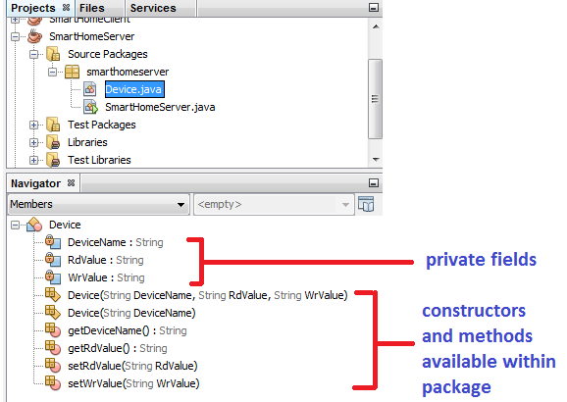

## package SmartHomeServer -> class SmartHomeServer

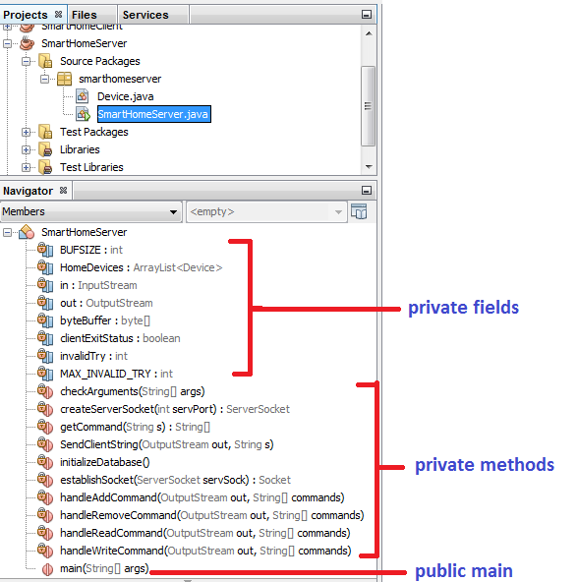

# Flow Chart of SmartHomeServer

## Legends of colour code

Green – start of a method Red – end of a method Dark Orange - exception

Yellow – decision making Blue – processing/execution

## Method: public static void main (String[] args)



## Method: private static void checkArguments(String[] args)



## Method: private static ServerSocket createServerSocket(int servPort)



## Method: private static String[] getCommand (String s)



## Method: private static void SendClientString(OutputStream out, String s)



## Method: private static void initializeDatabase()



## Method: private static Socket establishSocket(ServerSocket servSock)



## Method: private static void handleAddCommand (OutputStream out, String[] commands)



## Method: private static void handleRemoveCommand (OutputStream out, String[] commands)



## Method: private static void handleReadCommand (OutputStream out, String[] commands)



## Method: private static void handleWriteCommand (OutputStream out, String[] commands)

